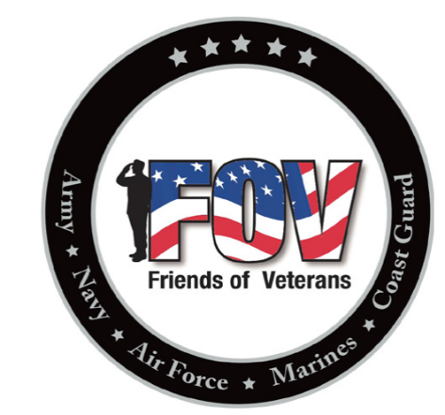
Friends of Veterans
Membership form

MEMBERSHIP FORM – Turn into Friends of Veterans member or the bartender at the Rosemount VFW Post 9433 along with $5 (cash or check) for the annual dues.
Please print clearly.
First Name
Last Name
Address (Line 1)
Address (Line 2)
City
State
Postal Code
Country
Telephone Number
Email Address
Military Affiliation (optional) | (Military affiliation is not required to be a member)  Air Force Army Coast Guard Marine Corps. Navy  None

Make checks payable to: Friends of Veterans

Friends of Veterans
2625 – 120th Street West
Rosemount, MN 55068

Thank you for your support!

